**UNIVERSIDAD DE LAS FUERZAS ARMADAS – ESPE**

1. User story

1.- The user told us that to enter the subway station the first thing to do is to buy a card, which came included with a recharge of 13 trips, after that tour he walked to the ticket office and at that very moment he can choose where he will go, after that pass the card to register the trip and once passed the card digitally, a trip is deducted, from there he went down some escalators and went to the subway platform where he waited for the subway, when the subway arrived the doors opened automatically because if not he had the possibility to press a button, only if it was in green, because if it was in red/orange it will not let you press it and the subway will stop for about 30 minutes.

1. User story

2.- Mobility only in the city

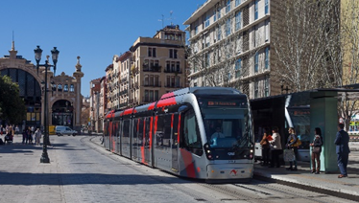

To purchase the ticket to enter the tram, tickets are purchased at the same stop.

Different tickets:

**One trip ticket:** paying 1.40 each trip

**Ticket with several trips and pay your friends:** paying € 5 or at most € 50 having a card which is economical because you can make transfers, that is, for an hour you can pay € 1.40 and get on the tram several times, but not from the same stop, this card is also valid to get on the bus.

**Tickets for season tickets 30, 90, 365**days: with this you can get on the tram and the bus as many times as you want, but only by paying your ticket you can not pay your friends.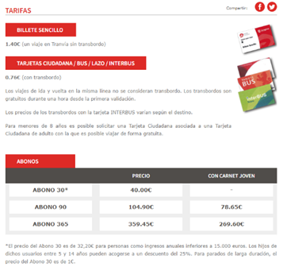

**TYPES OF CARDS AND BONUSES**

Mobility to go to another city

To purchase the ticket can be from the station (where you taker the ave or train) or online, the price varies according to the destination, if you buy the ticket with a month off before traveling and leave little cheaper than taking it the same day:

Example:

Hor trip to Madrid, a trip of 1 hour and 19 minutes

Trip for January 3, buying it from today

1. User story

I left the house and walked to the metro station which is a distance of 1 kilometer. It is about a 12-15 minutes walk to get to the station.

to enter the station i have a monthly card which costs 970kr, it is recharged month by month as it is a rechargeable card, i swipe it at the entry machine, it opens the doors and i enter the metro station, I usually know at what time the subway passes through the station so I calculate the time and leave the house or speed up the pace if I am late because the subways are punctual, I take the subway to a certain stop that is about 20 minutes and again I go to another subway that takes me to work, it takes about 15 minutes to reach my final destination.

To recharge the card, every time I go through the entry machine I get a warning if the card has expired, normally it is recharged every month, there are some machines and I recharge it for 30 days, and I pay it with my debit card.

1. User story

The user walks one kilometer from his home to the nearest metro station, at the station he buys a ticket for each time he is going to take the metro, to buy the ticket when he is near the station this user opens an application of the trains called SL and goes to the buy option where he has the possibility of different tickets such as a single ticket that has a duration of one hour and thirty minutes in which he can travel wherever he wants during that time so he leaves the train and can re-enter while he is in the range, there are also tickets that can last for days if you use the subway often, no matter the destination, the number of stops or the number of times you enter and exit the train the ticket does not change its value, the single ticket has an approximate cost of 4.50$, the payment is made through the application which gives you several payment options, such as one called swesh which is like an automatic bank transfer, when you pay the ticket is activated and gives you the ticket which is a QR code, from the moment of payment the ticket begins to count the time of validity of the ticket, in the station there are automatic doors that open after passing the ticket through a reader, when you enter you walk to the line you are going to use and wait for the subway to arrive, the other option is to plan the trip in advance and arrive at the station a little before the subway arrives and when the stop you are going to get off you can leave the station without any problem.

User Story 5

To start I walk 3 to 4 blocks to get to the station closest to my house, when I arrive I have two options approach a ticket office or open the train app to buy a ticket, the ticket is digital and works for time which has a minimal difference in costs that vary from 3 to 5 dollars, when you have your ticket you pass it through a reader and at the station you wait in line for the train you are going to take, When the train arrives if the train does not open it has a button to open the doors only if it is green because if it is another color it is a failure in the system that will make it take half an hour to open, in the train you can go sitting or standing depending on how full it is, at the station to get off you have a part where it shows you the time you have left.

-Requirements

- The system shall use a multimodal card.

- The system shall allow the passengers to resort to an emergency button.

-The system will allow users to purchase tickets through: deposits, transfers and payments to counters.

-The system will have a register and control of passengers through a database that will provide their ID and passport number in case of foreigners.

-The system shall have access to the register of control and the list of the employees only for the administrators.

-The system shall share the schedule to the passengers.